Tutorial: How to Set up VSCode Like a Professional In 5 Minutes

# How to edit settings.json in Visual Studio Code:

1. Open command palette (Ctrl + Shift + P on Windows or Cmd + Shift + P on Mac)
2. Type “settings JSON”
3. Click the top item (“Preferences: Open Settings (JSON)”)

# Replace your settings.json file using mine:

{

  "files.autoSave": "onFocusChange",

  "editor.fontLigatures": true,

  "editor.fontFamily": "Fira Code SemiBold, Consolas, 'Courier New', monospace",

  "editor.fontSize": 20,

  "editor.wordWrap": "wordWrapColumn",

  "prettier.semi": false,

  "editor.codeActionsOnSave": { "source.fixAll": true },

  "editor.defaultFormatter": "esbenp.prettier-vscode",

  "editor.formatOnPaste": true,

  "editor.formatOnSave": true,

  "editor.formatOnType": true,

  "eslint.alwaysShowStatus": true,

  "html.format.enable": false,

  "htmlhint.enable": true,

  "prettier.requireConfig": false,

  "prettier.useEditorConfig": true,

  "[html]": {

    "editor.defaultFormatter": "esbenp.prettier-vscode",

    "editor.formatOnSave": true

  },

  "[javascript]": {

    "editor.defaultFormatter": "esbenp.prettier-vscode",

    "editor.formatOnSave": true

  },

  "[json]": {

    "editor.defaultFormatter": "esbenp.prettier-vscode",

    "editor.formatOnSave": true

  },

}

# Install extensions in VSCode:

**ESLint**, **HTMLHint**, **Live Server**, **Prettier – code formatter**, **stylelint**, and your choice of theme

*(You only need to install one theme; I suggest* ***Monokai Vibrant****,* ***Monokai Pro****, or* ***Shades of Purple****)*

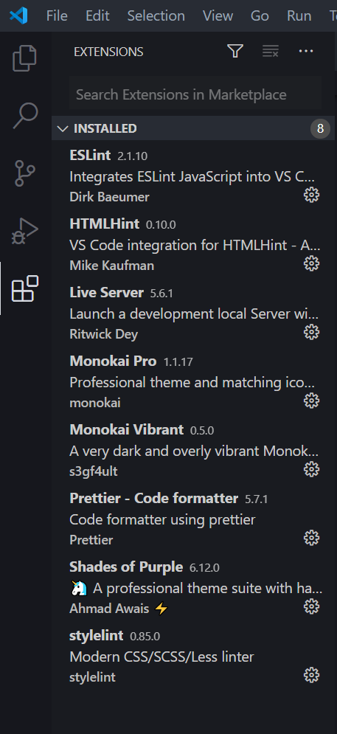

# Choose a theme to be your active theme:

1. Click the theme (or the gear next to the theme) in the extensions list
2. Click “Set Color Theme”  
   *(Screenshot below)*
3. Click the name of the theme at the top, where a dropdown menu says “Select Color Theme”

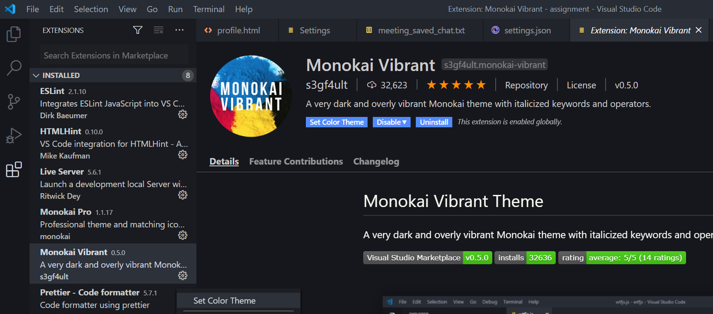

# Set up Prettier to remove semicolons (optional, but recommended):

1. In the extensions sidebar, open up Prettier’s settings by clicking on the gear and “Extension Settings”  
   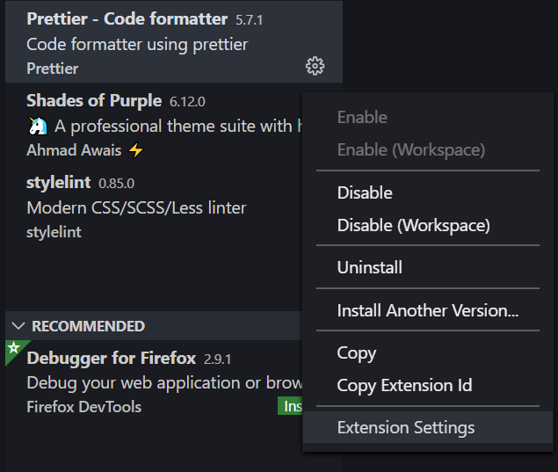
2. Add the word “semi” to the search bar (or scroll down until you find the setting):  
   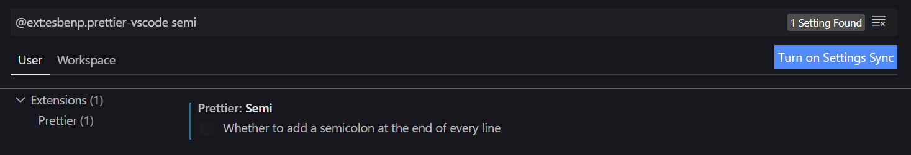
3. Click to remove the checkbox for the setting Prettier: **Semi**. In other words, it sets the Prettier configuration setting "semi": false – turning off semicolons when programming in JavaScript.

***Note about "semi": false***: When collaborating with others you would use a Prettier configuration file, usually named .prettierrc, and this is considered best practice.  
  
For example, if you opened someone else’s file and removed all their semicolons, they would probably be mad at you. But, if they have a .prettierrc file containing the entry "semi": true, then your system would automatically use their settings (use semicolons).

You can also toggle the setting off. Again, this is getting a bit advanced, which is why it’s optional for the tutorial – but it’s good to know how Prettier settings work for collaboration.

# Add Fira Code font and turn on ligatures (optional, but recommended):

1. Download the Fira Code fonts from <https://github.com/tonsky/FiraCode>   
   à Direct download link as of June 12, 2020:   
    <https://github.com/tonsky/FiraCode/releases/download/5.2/Fira_Code_v5.2.zip>
2. Extract the fonts (.ttf files) somewhere, such as your Desktop
3. Instructions differ for Mac OS vs. Windows  
   à Copied from <https://github.com/tonsky/FiraCode/wiki/Installing>
   1. **Mac OS**
      1. In the downloaded TTF folder (“\Downloads\Fira_Code_v5.2\ttf”):
         1. Select all font files
         2. Right click and select Open (alternatively Open With Font Book)
         3. Select "Install Font"
   2. **Windows 10**
      1. In the ttf folder (“\Downloads\Fira_Code_v5.2\ttf”)
         1. Unblock each font file “On some systems (especially Windows 10), you may need to "Unblock" each font file before installing. To do so, **right-click** each font file, click **Properties**, then check **Unblock** next to Security at the bottom of the General tab. Click **OK**, and then install. Note: Skipping this step may cause the Fira Code fonts to intermittently stop working in VS Code, even though the fonts still appear in other programs.” à Do this 6 times, for each font file.  
              
            (Screenshot on next page)
         2. Select all font files
         3. Right-click and choose “Install”
4. The VS Code settings to use “Fira Code SemiBold” as the default font, to turn on font ligatures (fancy arrows and other programming features), and to use 20pt size font were all configured in the settings.json file configured in the first part of the tutorial.  
     
   You can change them there, or by opening up the settings normally and typing “font” to look at the font settings. Similarly, you can change word wrap by searching “word wrap.”

***Screenshot of unblocking fonts on Windows 10***

